**ScratchX Algobrix Tutorial**

* How to use Algobrix with ScratchX
* Understand the correlation between Algobrix coding blocks and the ScratchX commands.
* Practice using hands on experience with several examples to understand the concept of working with the Algobrain ScratchX Extension.

# The Algobrix coding blocks:

**Play Block**

**Play Block:** a brick that read the entire tangible command sequence, converts it to a binary representation (“0”, “1”), and transmits such command sequences to the robot’s Brain.

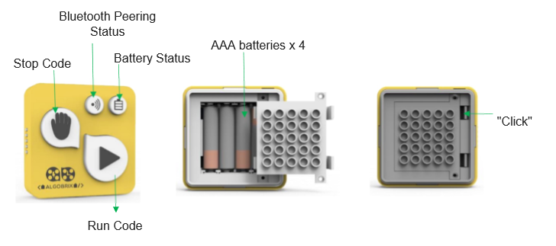

**Function Blocks**

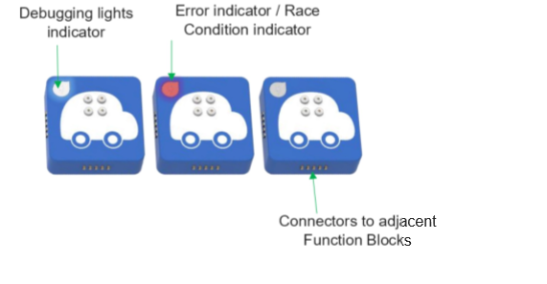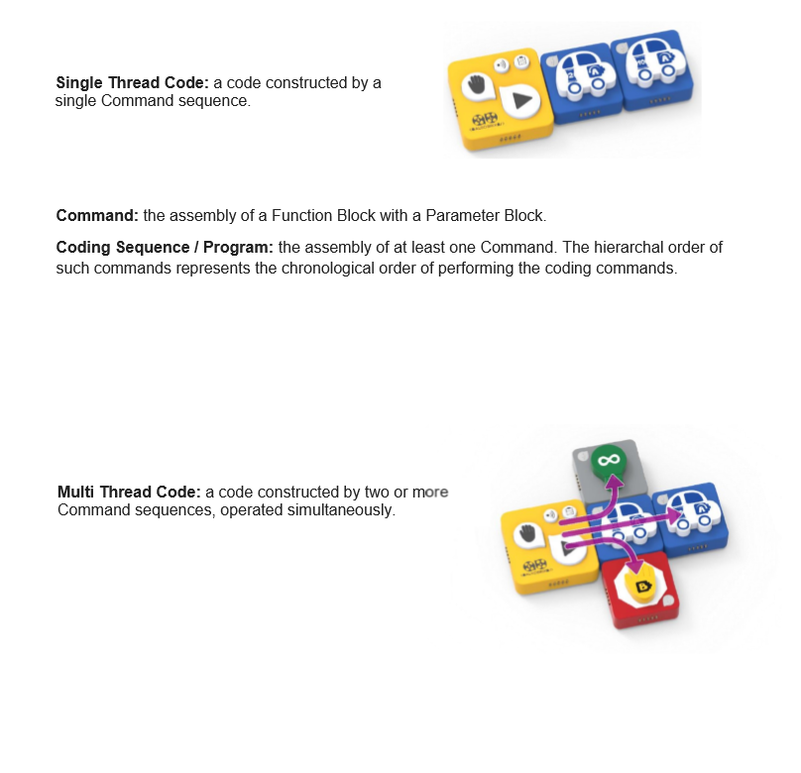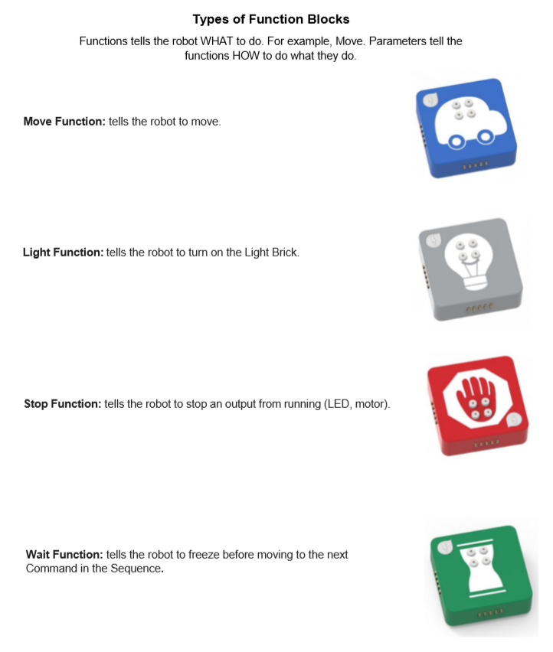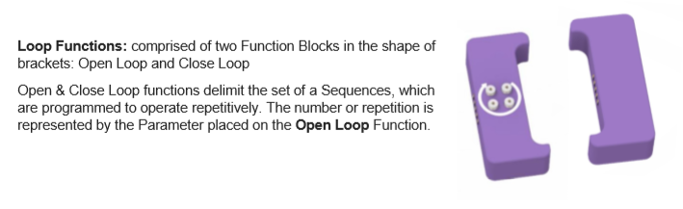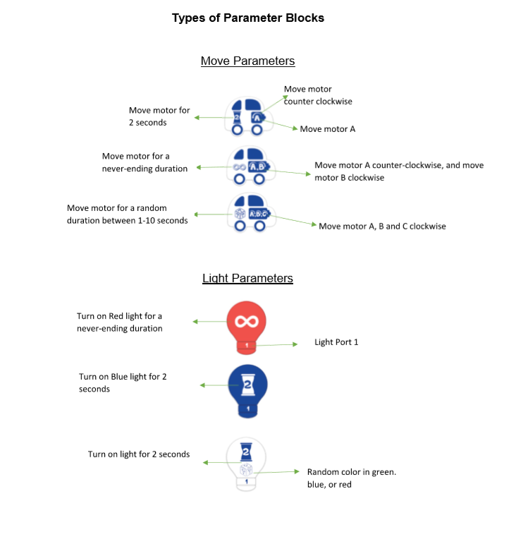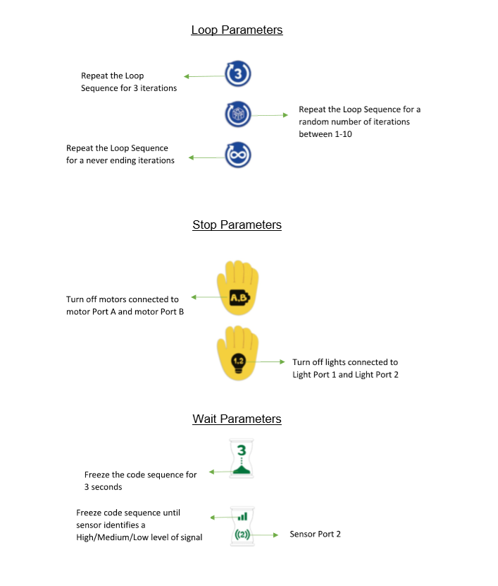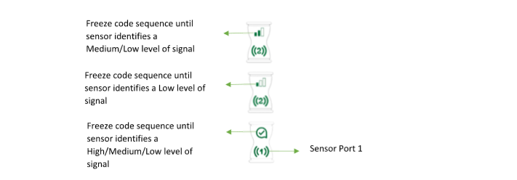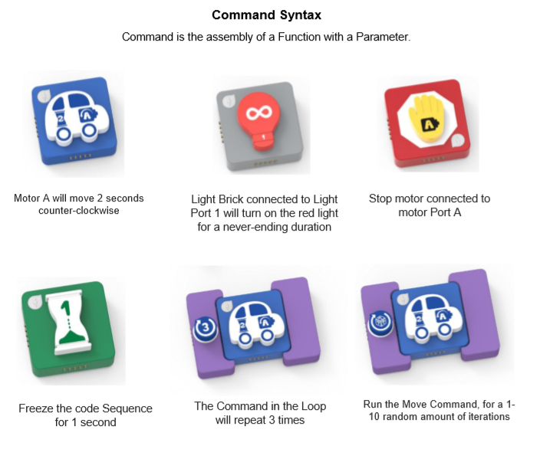

# ScratchX Extension:

We will take 3 examples of Algobrix, explain each one and show how we can make the same code with the ScratchX Extension!

**Example 1:**

* The Following code will start a loop of 3 Iterations, meaning the code inside will repeat 3 times.
* The 1st cube inside the loop waits for a LOW value from the connected sensor #2.
* The 2nd cube inside the loop will turn the LED #1 on for 1 second in the blue color.

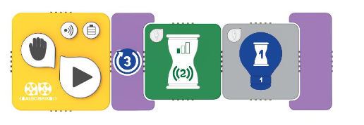

With ScratchX it will look like so:

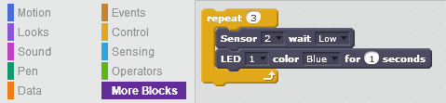

The Orange Block is the loop block in our case, you can access those from the “Control” category on the left panel.  
The Blocks inside if in Bluish Gray are the extension blocks and you can access those from the “More Blocks” category.

**Example 2:**

* 1st Cube will turn motor A on, it will turn Clockwise and will do it forever. (hance the infinity sign)
* 2nd Cube will wait 3 seconds
* 3rd Cube will stop motor A

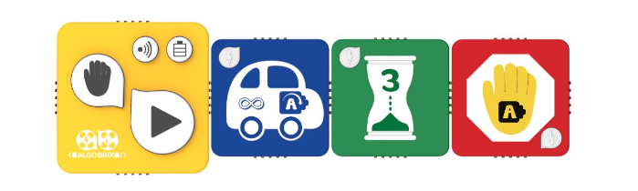

With ScratchX it will look like so:

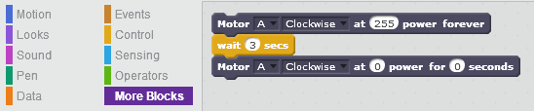

Same as case 1, the Orange blocks can be found at ”Control” and the Bluish Gray at “More Blocks”.  
As for the motor controls, power is a value between 0-255.  
Stopping a motor is setting its power for 0 for 0 seconds.

**Example 3:**

* Start with open loop of 10 Iterations (repeat for 10 times)
* Motor A (Counter Clockwise) and Motor B (Clockwise) will turn on Forever.
* Waiting for a LOW value on Sensor #2
* Stop BOTH Motor A and B
* Turn Motor A Clockwise for 3 seconds.

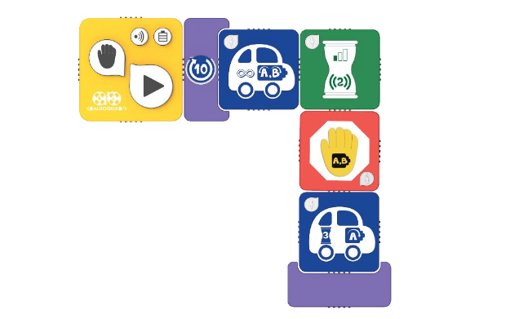

With ScratchX it will look like so:

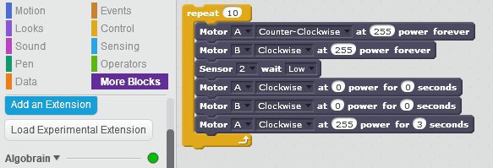

Nothing new from the last 2 cases, just an example of them both at once, if something is unclear, return to cases 1 and 2! Good Luck!